实验七 运算符重载
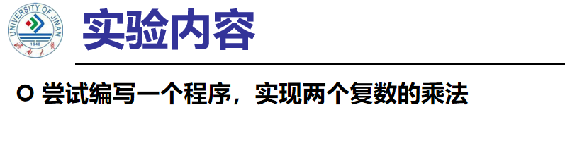
代码：
#include<iostream>
using namespace std;
class Complex {
public:
double real, img;
Complex(double r = 0 ,double i = 0)
{
real = r;
img = i;
}
};
Complex operator*(Complex a, Complex b)
{
Complex temp;
temp.real = a.real * b.real-a.img*b.img;
temp.img = a.real * b.img + a.img * b.real;
return temp;
}
int main()
{
double a,b,c,d;
cout << "请输入两个复数的实部和虚部" << endl;
cin >> a >> b >> c >> d;
Complex A(a, b);
Complex B(c, d);
Complex temp;
temp = A * B;
cout << "乘积的实部是：" << temp.real << endl;
cout << "乘积的虚部是：" << temp.img << endl;
return 0;
}
结果：
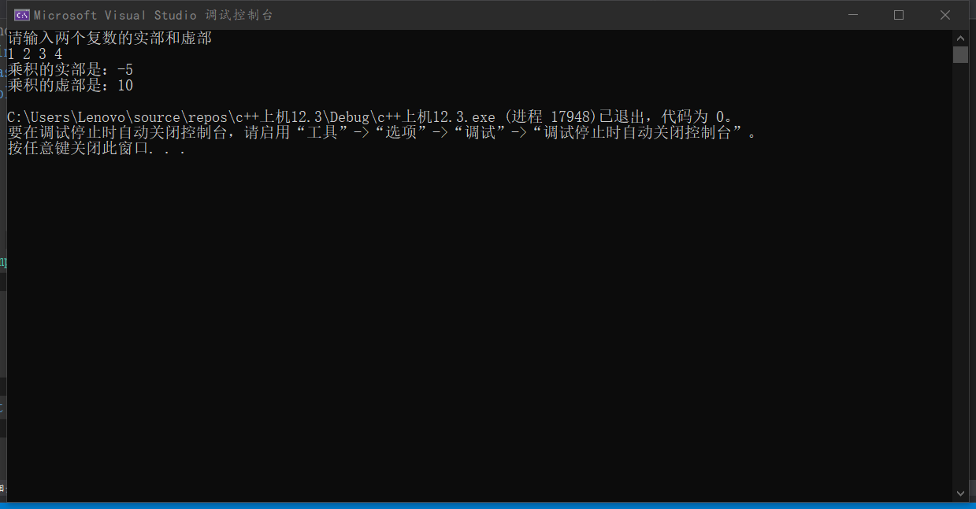
心得：
运算符重载是通过创建运算符重载函数来实现的。运算符重载体现了C++的多态性。运算符重载是针对新类型数据的实际需要，对原有运算符进行适当的改造完成的。重载不能改变运算符的操作对象的个数。

Copyright ©2021-2099 Junyang Feng. All rights reserved

